Summer Concert
Sunday, August 1st
From 3:00-6:00 PM
Crockett Community Center
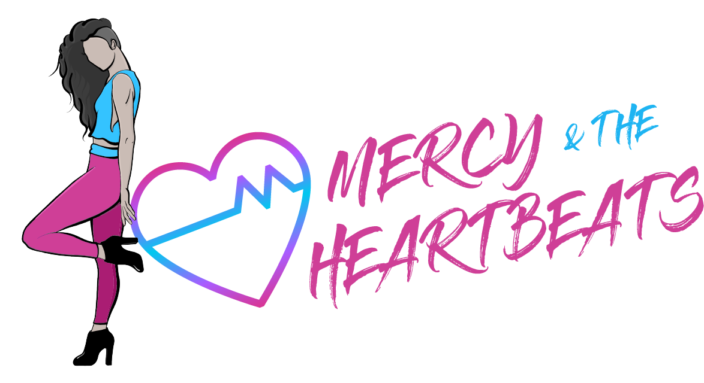
This Event was made possible by the Crockett Community Foundation

